[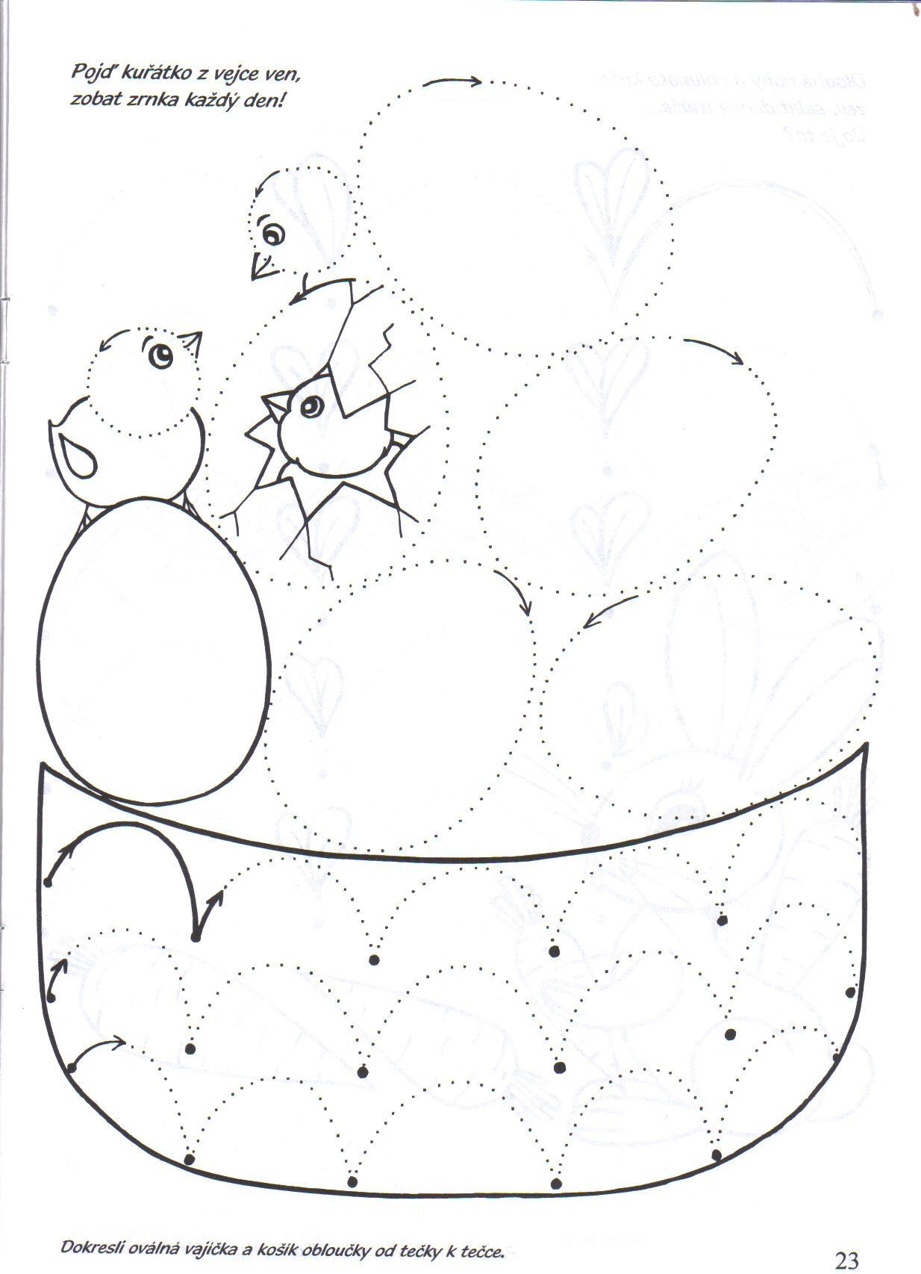](https://www.google.cz/url?sa=i&url=https%3A%2F%2Fwww.pinterest.ru%2Fpin%2F481251910175880646%2F&psig=AOvVaw0fL79PxpoyI0696RdygPT2&ust=1586890371922000&source=images&cd=vfe&ved=0CAIQjRxqFwoTCKjH3NKJ5ugCFQAAAAAdAAAAABAV)